LAB ASSIGNMENT V : HUERISTIC EVALUATION
SYSTEM EVALUATED : __________
Groups members NAME : ………………………………………………….
**Evaluation to be done by other Group
PART I : HUERISTIC EVALUATION BASED ON NIELSEN'S 10 GENERAL PRINCIPLES FOR INTERACTION DESIGN. (0 is lowest and 10 is highest)
S.No. | Heuristic Evaluation Parameter | Mention Violation if any | Severity 0-10 (0- minimum and 10 is maximium) | Ways to improve
1 | User Control: Interface will allow the user to perceive that they are in control | Many Navigation options are available on the Home and Dashboard screens. | 7 | Keep navigation options clear and provide easy Home page for every type of user.
2 | Human Limitations: Interface will not overload the users cognitive, auditory and motor skills | Home and dashboard contain several categories and actions. | 8 | Reduce the number of options shown at once and highlight important actions such as consult doctor and Medicines.
3 | Accommodation: The interface will fit the way each user group works and thinks (personas) | Different users may have different healthcare needs. | 6 | Provide more personalized options according to user needs.
4 | Linguistic Clarity: Interface will communicate as efficiently as possible | Some healthcare terms may be difficult for general users. | 6 | Use simple language and short descriptions.
5 | Aesthetic Integrity :The interface will have an attractive and appropriate design | Multiple cards and sections can make the interface look crowded. | 7 | Improving spacing, alignment and visual hierarchy.
6 | Simplicity: The interface will have a simple design | Home screen should be simple i.e. should not have complex interface which can confuse user. | 8 | Show important services first and move other options in categories.
7 | Predictability :The interface will behave in such a manner that the user can accurately predict what will happen next | Users may not always know what action will occur after selecting an option. | 6 | Use clear labels and consistent navigation.
8 | Accuracy: Interface will be free from errors | User can select am incorrect doctor, date or time while booking. | 7 | Show confirmation before booking.
9 | Technical Clarity: Interface will have the highest possible fidelity. | Some functions and icons may not be immediately understandable. | 6 | Use familiar icons with descriptive labels.
10 | Fulfillment : The interface will provide a satisfying user experience | Users may need to move between different sections to complete healthcare tasks. | 7 | Provide shortcuts to frequently used features from the dashboard.
11 | Consistency: Interface will be consistent | Some cards, buttons and icons may have different layouts across different sections. | 6 | Maintain the same button style, icons, fonts, color, and card layouts throughout all pages.
12 | User Support: Interface will provide additional assistance as needed or requested | Help and support may not always be immediately visible when users need assistance. | 7 | Keep Help, FAQs and Support easilt accessible from important screens.
13 | Precision: The interface will allow the users to perform a task exactly | Users may need multiple filters or selections to find the exact doctor, medicine or service. | 6 | Provide clearer search, filter and sorting options and display exact details before selection.
14 | Forgiveness: Interface will make action recoverable | Users may accidentally select the wrong doctor, medicines, date or time. | 8 | Provide edit, change, remove and cancel options before the confirmation.
15 | Responsiveness: The interface will inform users about the results of their actions and their interface status | Feedback for options such as selection, booking or loading may not always be prominent. | 7 | Clearly show selected sates, loading indicators, success messages and error messages after user actions.
 | Total Score |  | 102

Screenshots:
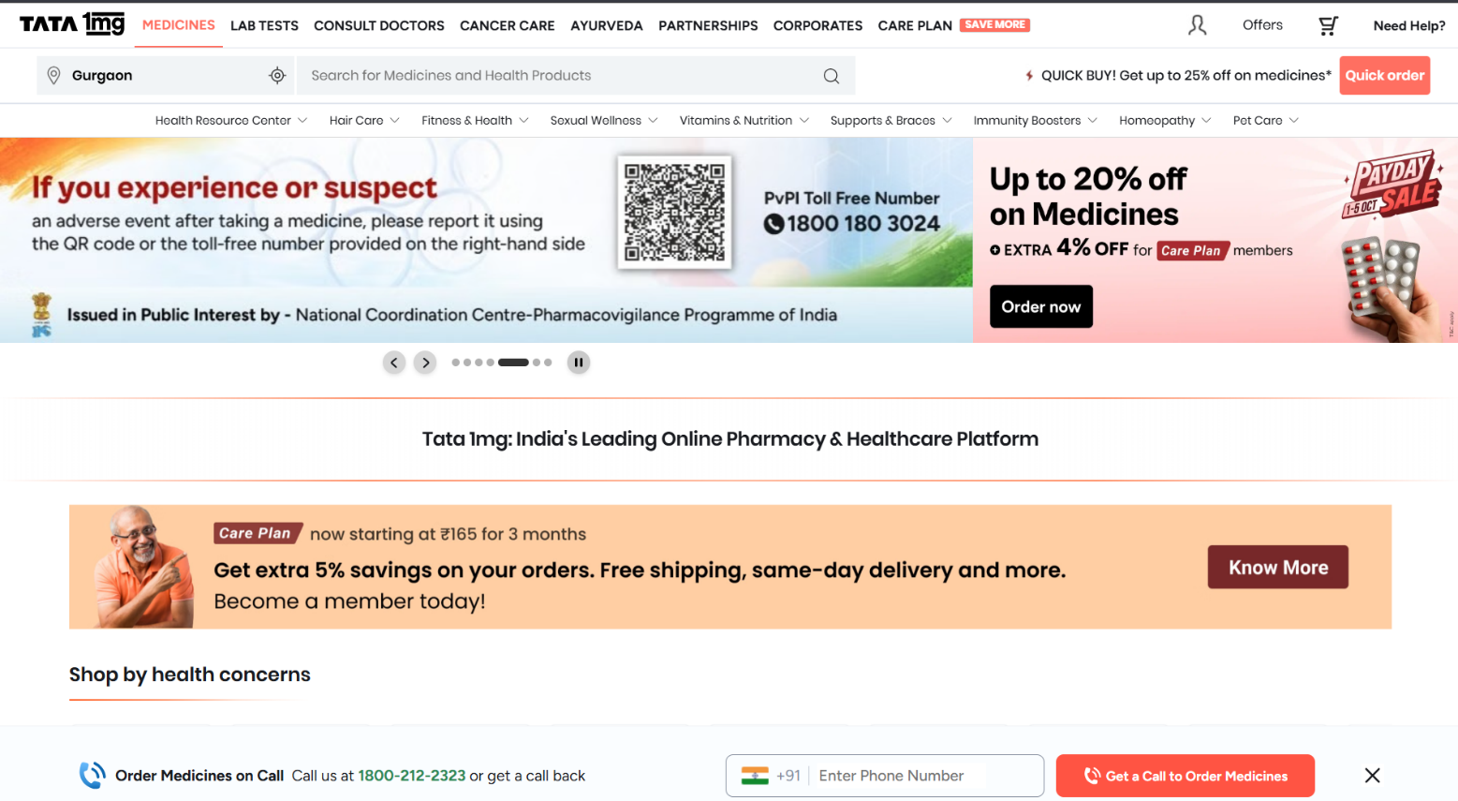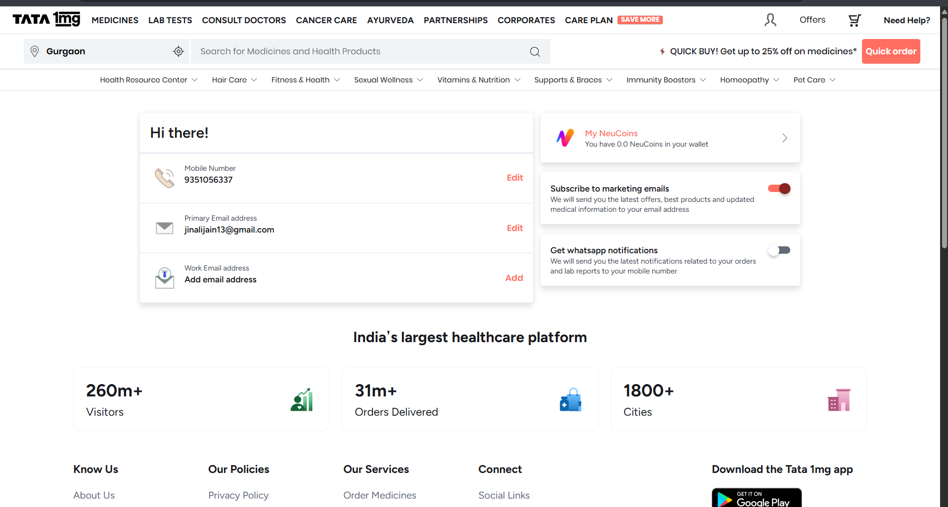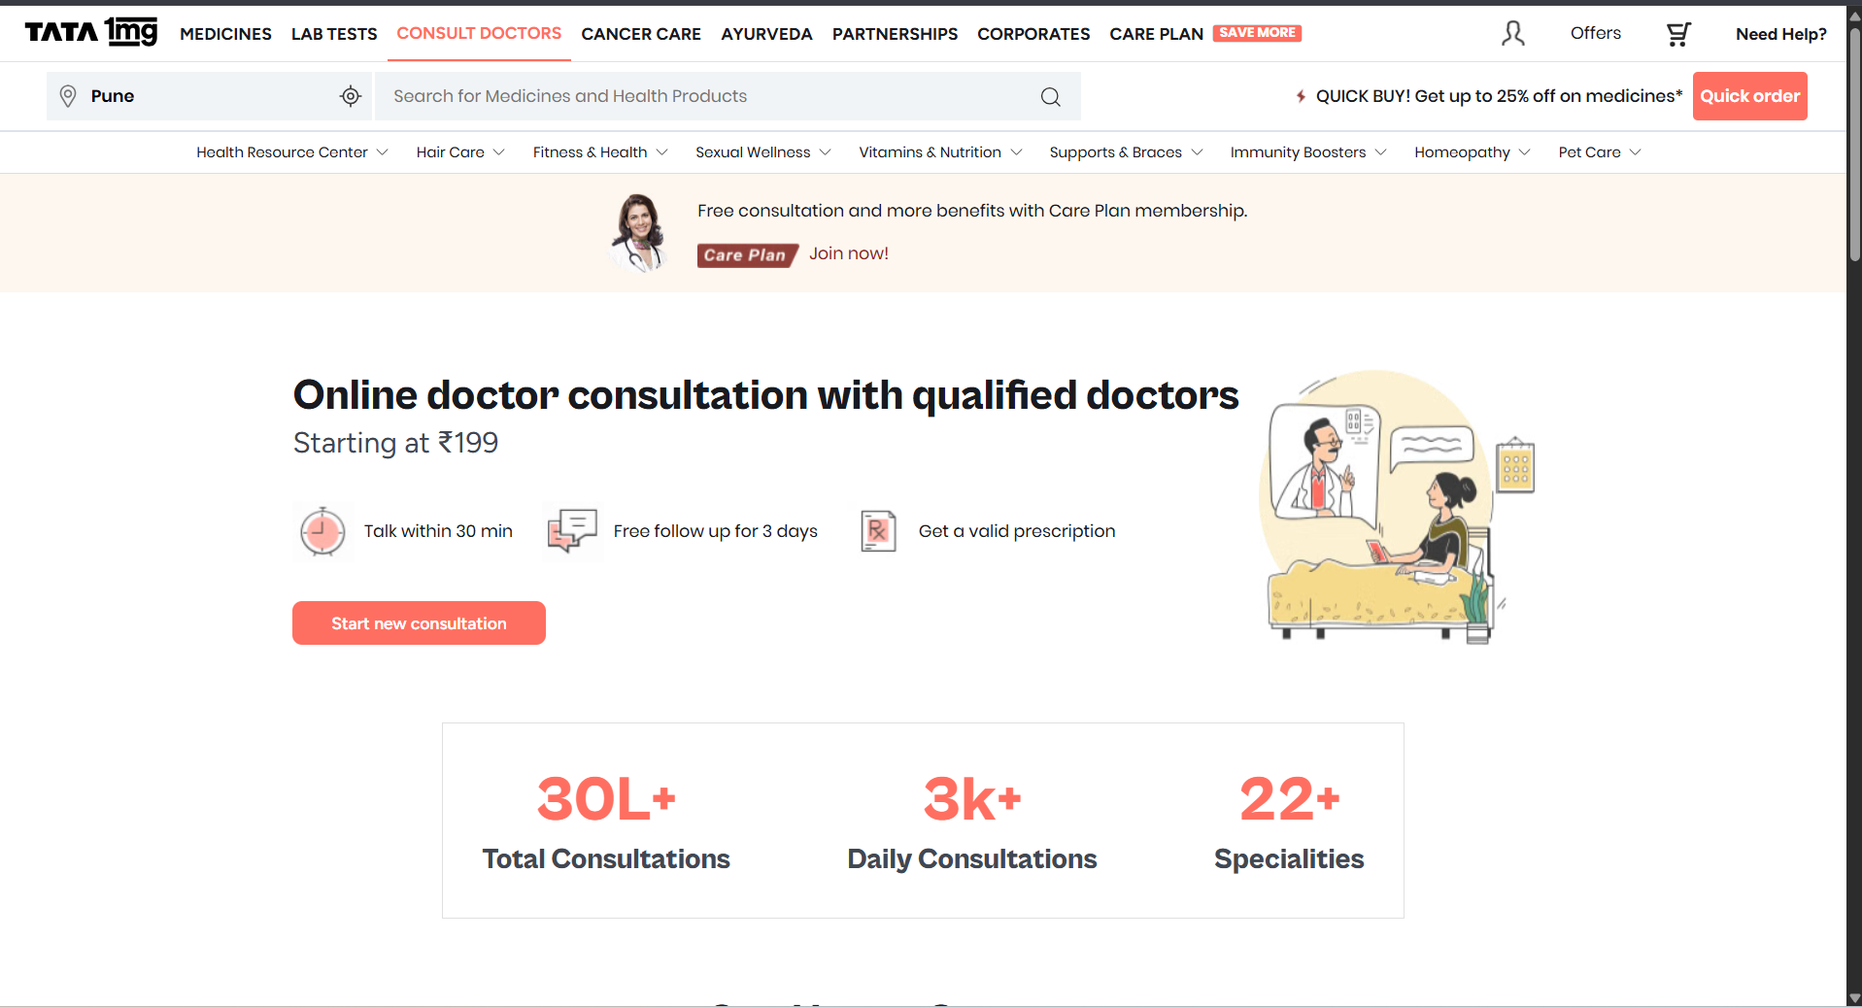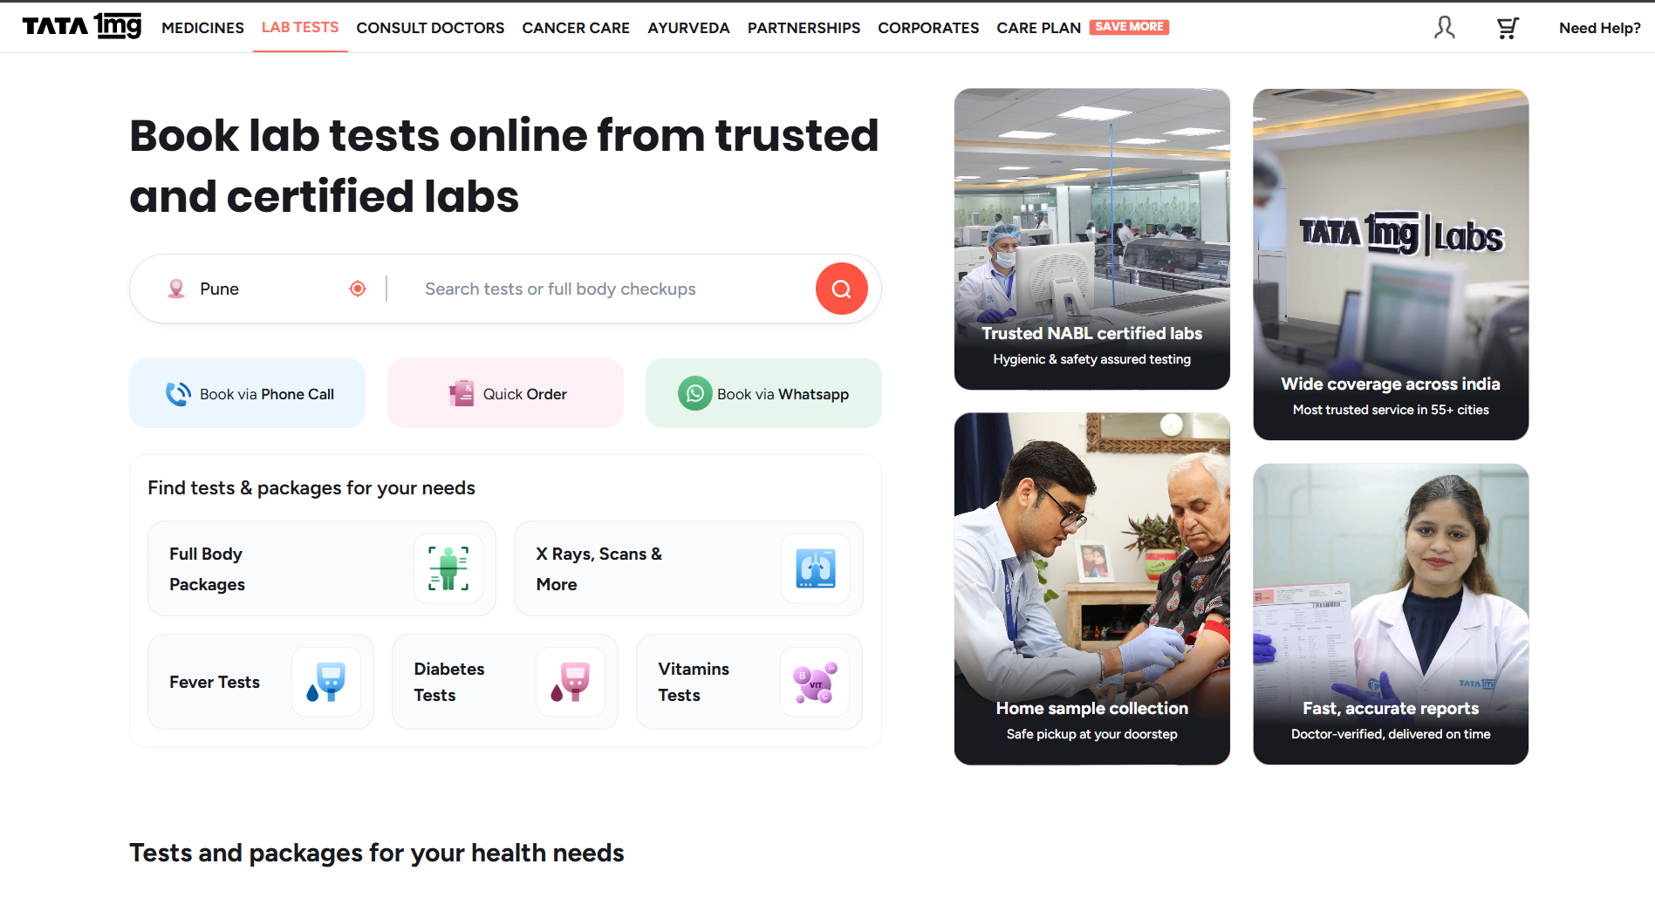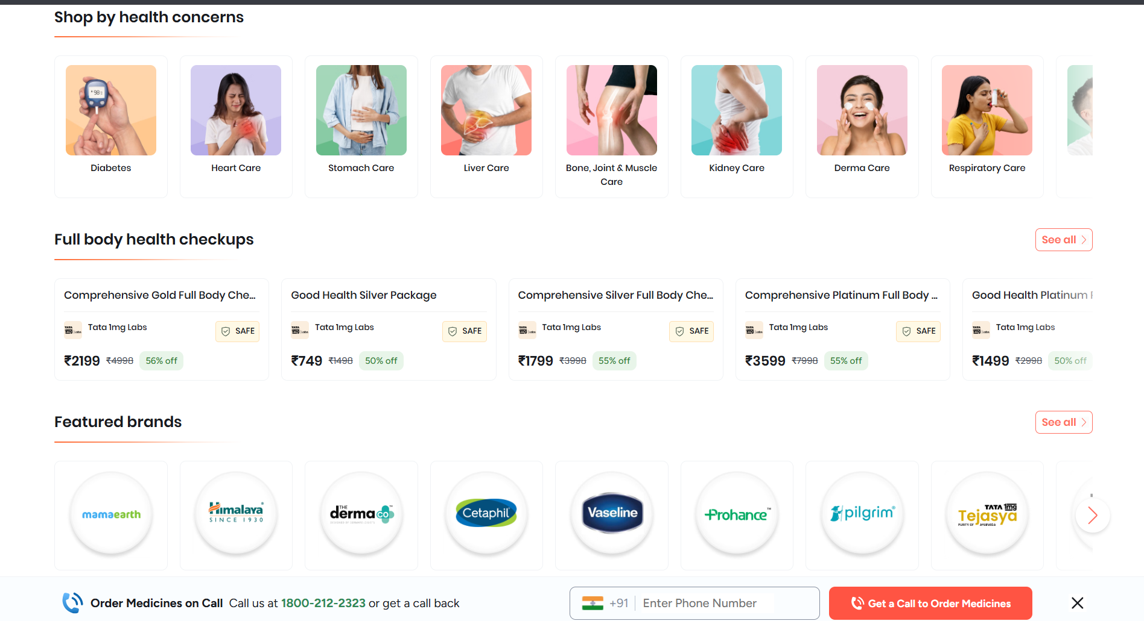

PART II : List out any other points that you may have missed out . (Other than Nielsen’s Principles)

S.NO | OBSERVATIONS | COMMENTS
1. | Personalization | Personalized recommendation according to user will make services easier to access.
2. | Privacy | Personal and medical information should be protected.

Students Evaluation Team : group that is evaluation ………………………………………………………………………………..

